**LIT ASSIGNMENT - DAY 11- Smart forms**

**EMP ID:46255236 Batch: SAP ABAP ON HANA.**

**Date: 17th Oct 2022.**

* **Customized employee Structure:**

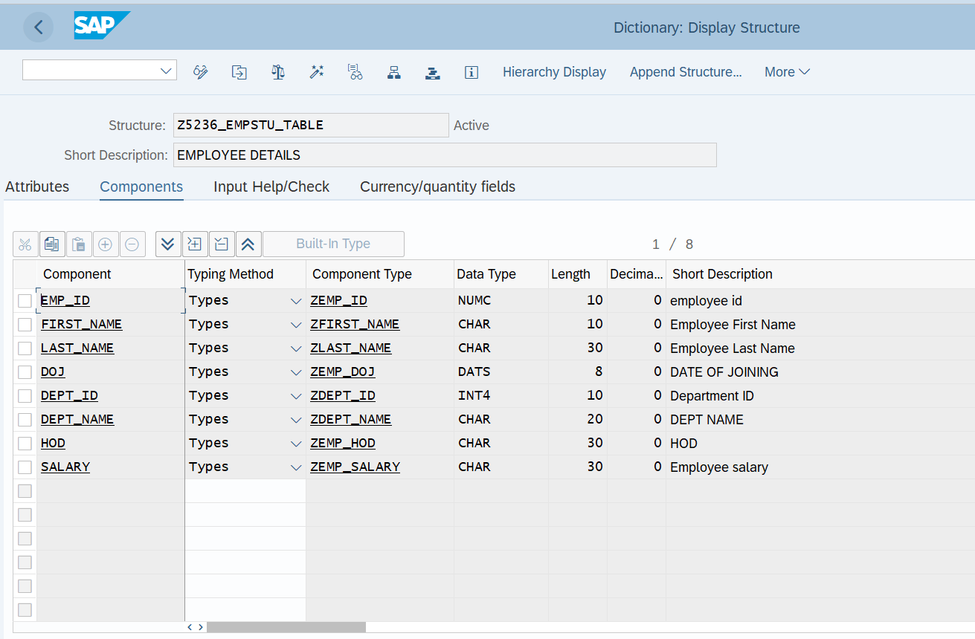

Exercise 1 – Creation of Smartform.

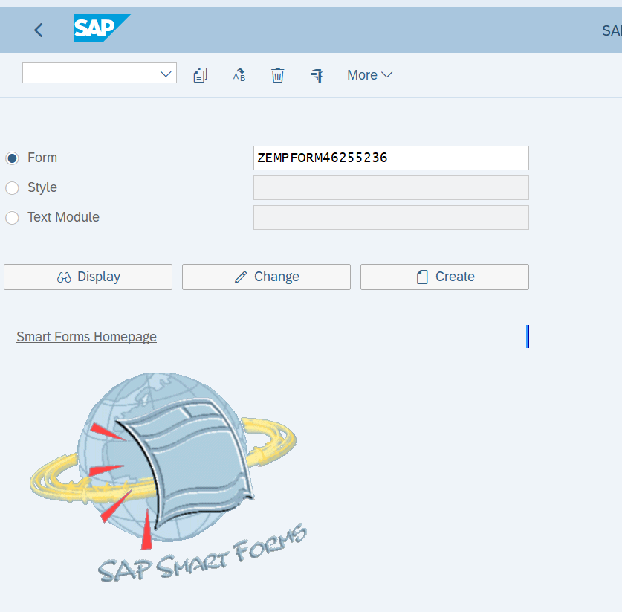

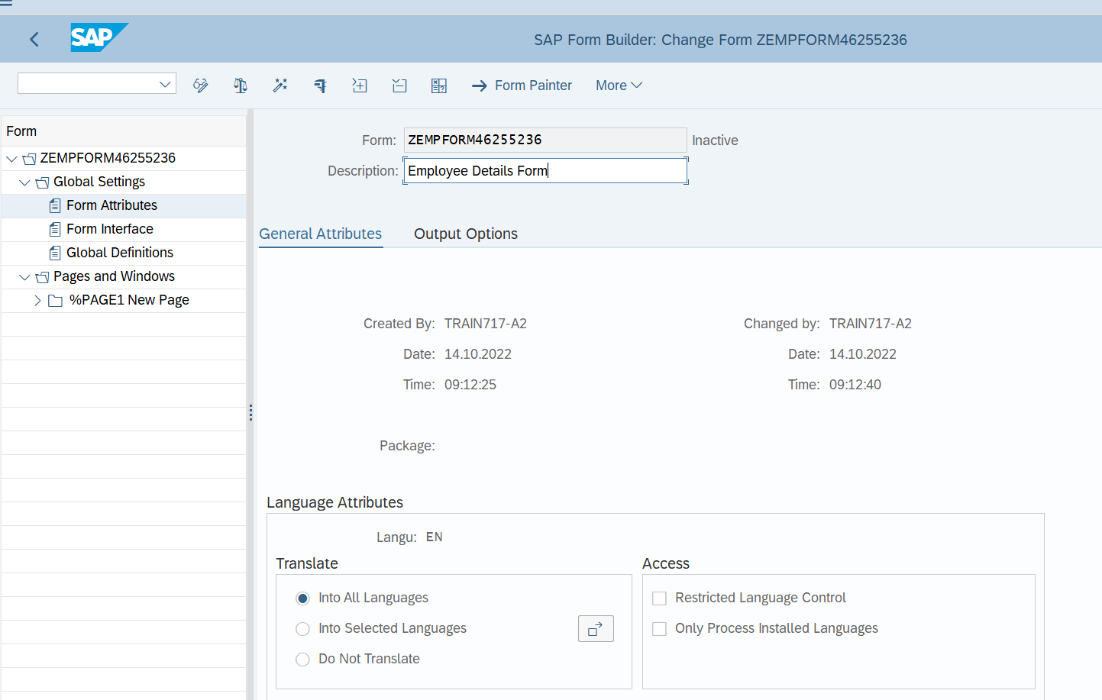

* **Windows with given requirements** .

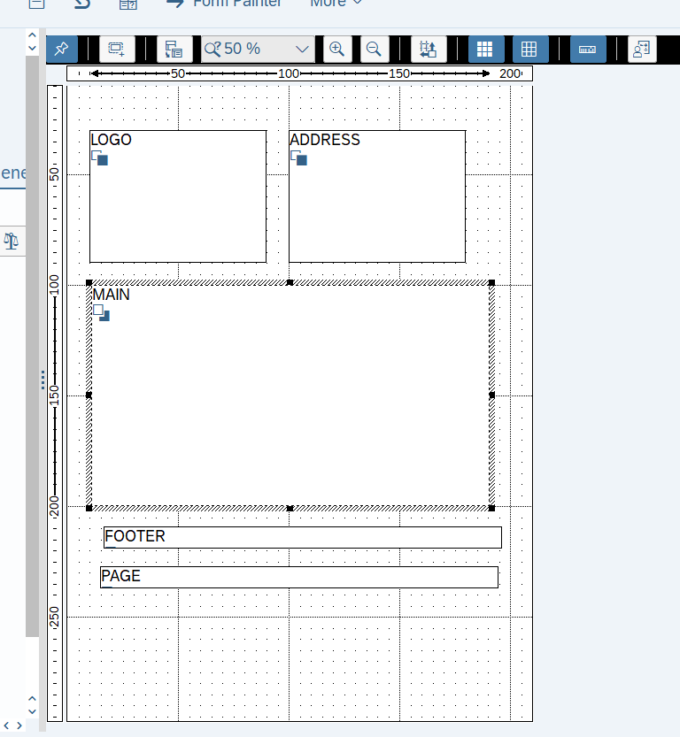

**Table definition**:

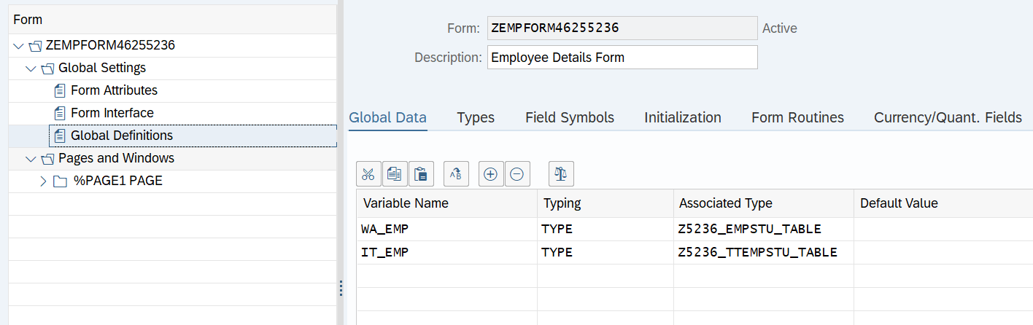

* **Graphics to insert logo** :

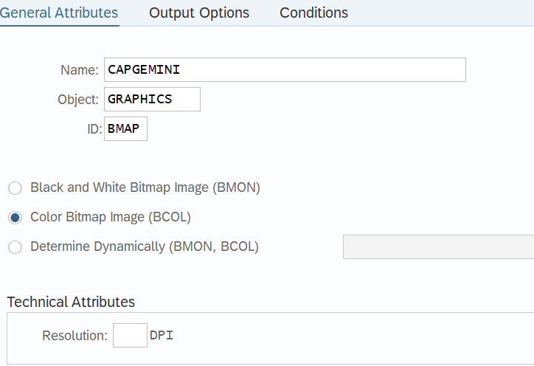

**FORM NODES:**

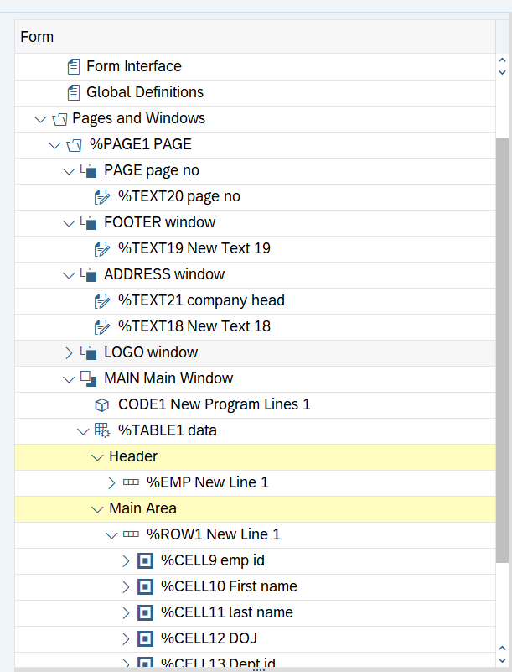

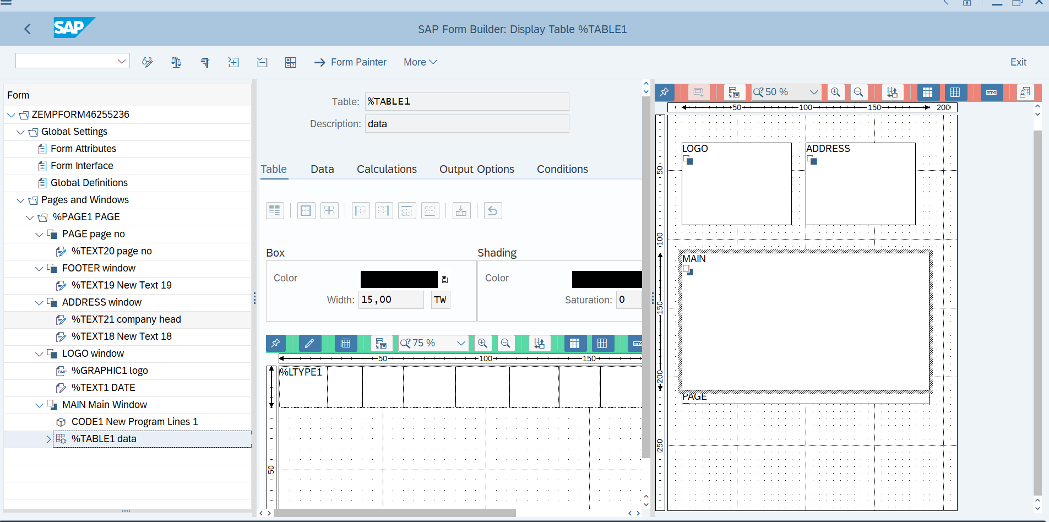

**Exercise 2 – Creation of Smart Style**

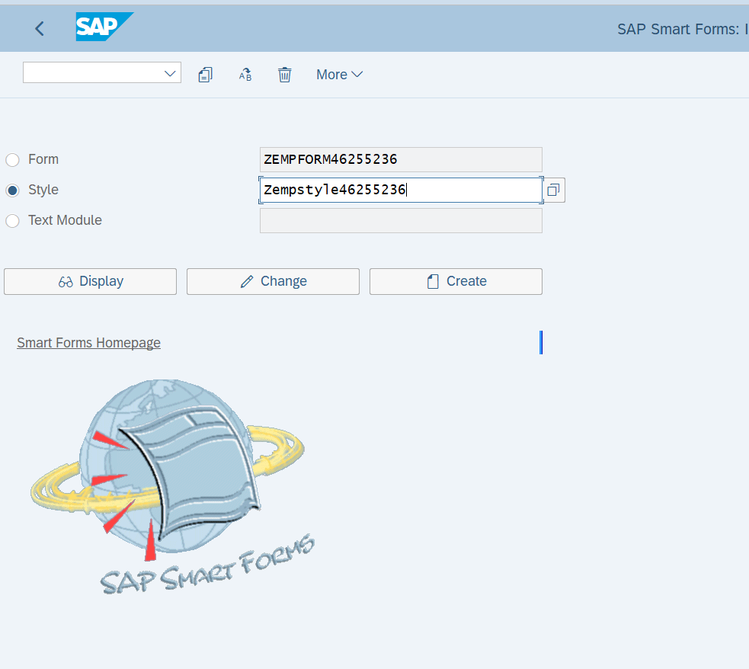

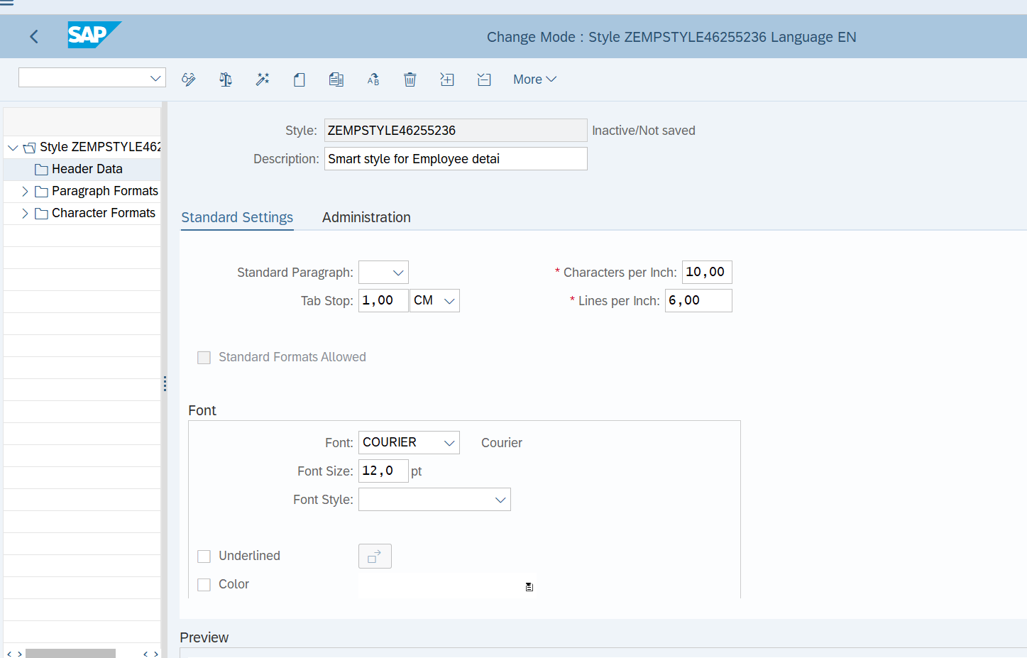

* **Create Paragraph formats**

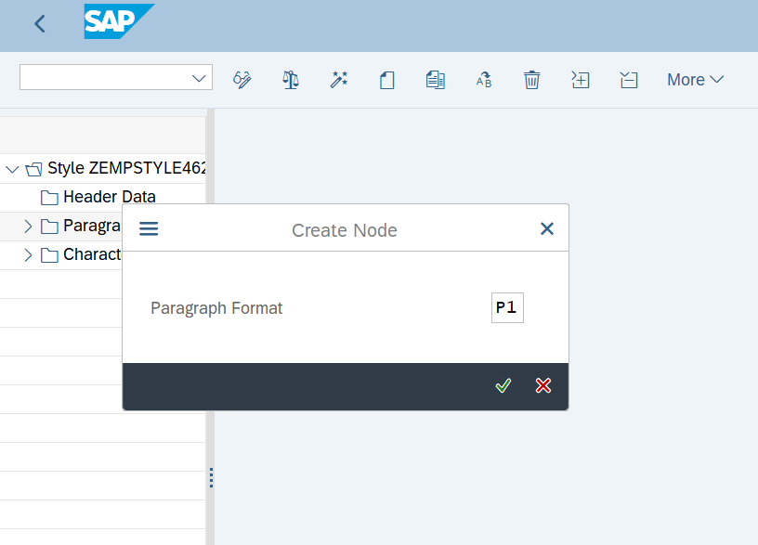

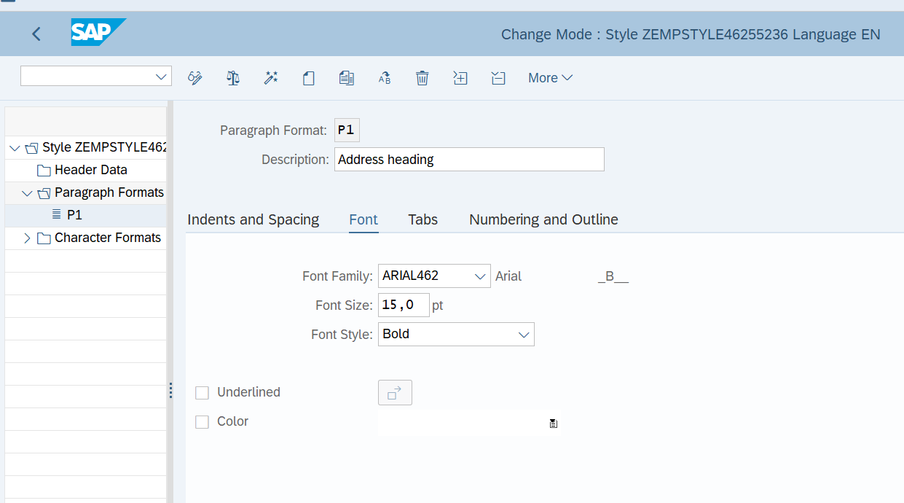

* **Specify the Smart style name in field "Style" under "Output Options" tab of Form Attributes.**

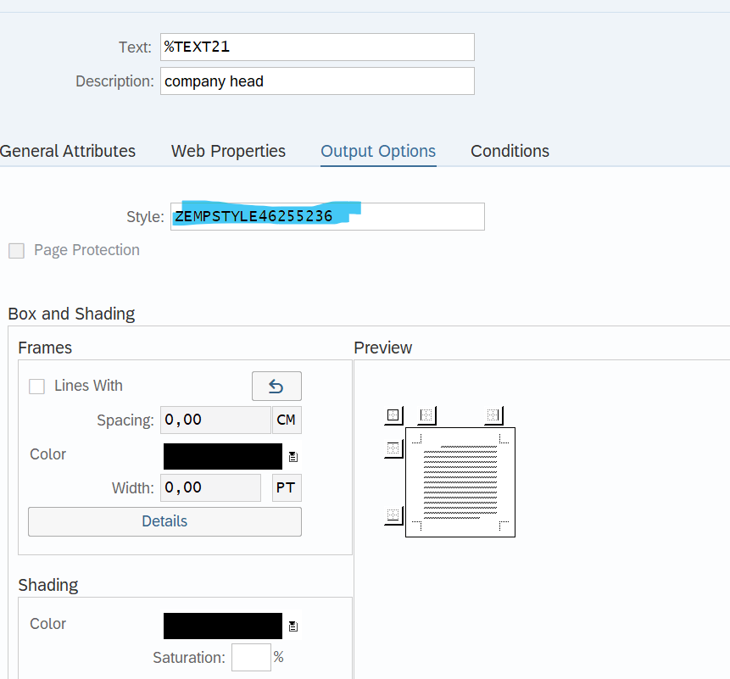

Exercise 3 – Calling Smartform from the ABAP driver program .

**REPORT:**

*&---------------------------------------------------------------------*  
*& Report Z5236_SMARTFORMS  
*&---------------------------------------------------------------------*  
* Description:     SMARTFORMS                                                    *  
*                                                                      *  
* Author:      ANJALI DEVI PALLAPU                                                        *  
*                                                                      *  
* Create date:          18/10/2022                                               *  
*                                                                      *  
  
  
TABLES:Z5236_EMP_TABLE.  
Data : fm_name TYPE rs38l_fnam.  
  
  
START-OF-SELECTION.  
PERFORM generate_smartform.  
  
  
FORM generate_smartform .  
CALL FUNCTION 'SSF_FUNCTION_MODULE_NAME'  
  EXPORTING  
    formname                 = 'ZEMPFORM46255236'  
  
 IMPORTING  
   FM_NAME                  = fm_name  
 EXCEPTIONS  
   NO_FORM                  = 1  
   NO_FUNCTION_MODULE       = 2  
   OTHERS                   = 3  
          .  
IF sy-subrc <> 0.  
* Implement suitable error handling here  
ENDIF.  
  
  
CALL FUNCTION fm_name  
* EXPORTING  
*   ARCHIVE_INDEX              =  
*   ARCHIVE_INDEX_TAB          =  
*   ARCHIVE_PARAMETERS         =  
*   CONTROL_PARAMETERS         =  
*   MAIL_APPL_OBJ              =  
*   MAIL_RECIPIENT             =  
*   MAIL_SENDER                =  
*   OUTPUT_OPTIONS             =  
*   USER_SETTINGS              = 'X'  
* IMPORTING  
*   DOCUMENT_OUTPUT_INFO       =  
*   JOB_OUTPUT_INFO            =  
*   JOB_OUTPUT_OPTIONS         =  
 EXCEPTIONS  
   FORMATTING_ERROR           = 1  
   INTERNAL_ERROR             = 2  
   SEND_ERROR                 = 3  
   USER_CANCELED              = 4  
   OTHERS                     = 5  
          .  
IF sy-subrc <> 0.  
* Implement suitable error handling here  
ENDIF.  
  
  
  
  
ENDFORM.

**OUTPUT:**

SMARTFORMS:

